Project Report Content (For Word Document)
1. Cover Page
- Project Title: Simple Python Calculator
- Course: Python Essentials
- Platform: VITyarthi - Build Your Own Project
- Student Name / ID: Aditya Tiwari
- Registeration Number – 26BAI10345
2. Introduction
This project is a terminal-based Simple Calculator written in Python. It demonstrates foundational programming principles such as modularity, control flow, and exception handling. By isolating operational logic from user interface components, the project serves as a scalable template for text-based Python applications.
3. Problem Statement
The objective is to design a fast, reliable command-line calculator that calculates standard arithmetic while actively preventing program crashes caused by invalid user inputs or illegal mathematical operations.
4. Functional Requirements
The system is built upon three major functional modules:
- User Interface Module (main.py): Displays a numerical menu (0-7) and captures user selections and variables[cite: 2].
- Arithmetic Module (calculator.py): Processes inputs through distinct mathematical functions (add, subtract, multiply, divide, modulus, power, square_root) and returns the resulting floats.
- Validation Module (validator.py): Intercepts inputs to ensure they are valid floats, rejecting zero during division and negative numbers during square root operations[cite: 3].
5. Non-Functional Requirements
The project satisfies the following criteria:
- Usability: The menu is clearly formatted, and the loop structure allows users to perform multiple calculations seamlessly without restarting the app[cite: 2].
- Maintainability: The code is cleanly separated into three distinct files (main.py, calculator.py, validator.py), allowing for easy updates.
- Error Handling Strategy: try-except blocks are utilized to catch ValueError and ZeroDivisionError exceptions gracefully[cite: 2].
- Reliability: The calculator will not crash unexpectedly due to typographically incorrect inputs[cite: 3].
6. System Architecture
The system utilizes a modular, procedural architecture. main.py acts as the controller, importing routing logic from calculator.py and data-sanitization rules from validator.py[cite: 2].
7. Design Diagrams
(Note: You must generate and insert these diagrams into your Word document)
- Use Case Diagram: An actor (User) interacts with use cases: View Menu, Input Numbers, View Result, and View Error Messages.
- Workflow / Process Flow Diagram: Start -> Show Menu -> Select Operation -> Input Numbers -> Validate Input -> Calculate -> Display Result -> Ask to Continue -> Loop or End.
- Component Diagram: Three boxes illustrating main.py connecting to both calculator.py and validator.py.
8. Design Decisions & Rationale
The primary design decision was the separation of concerns. Instead of placing all logic in a single file, the arithmetic functions were isolated into calculator.py and input checking into validator.py[cite: 3]. This rationale ensures that testing the math logic does not require interacting with the terminal UI.
9. Implementation Details
The project is implemented using standard Python 3. The __main__ idiom is used to prevent execution during module imports[cite: 2]. The built-in math library is utilized specifically for the math.sqrt() function[cite: 1]. Exception raising is implemented to pass specific, friendly string messages up to the main.py controller[cite: 3].

10. Screenshots / Results
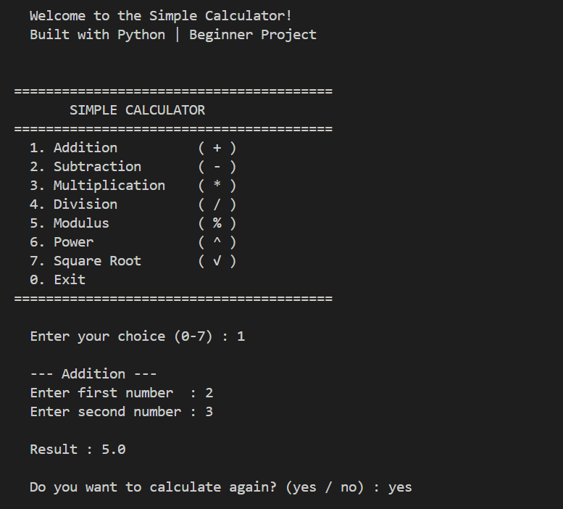
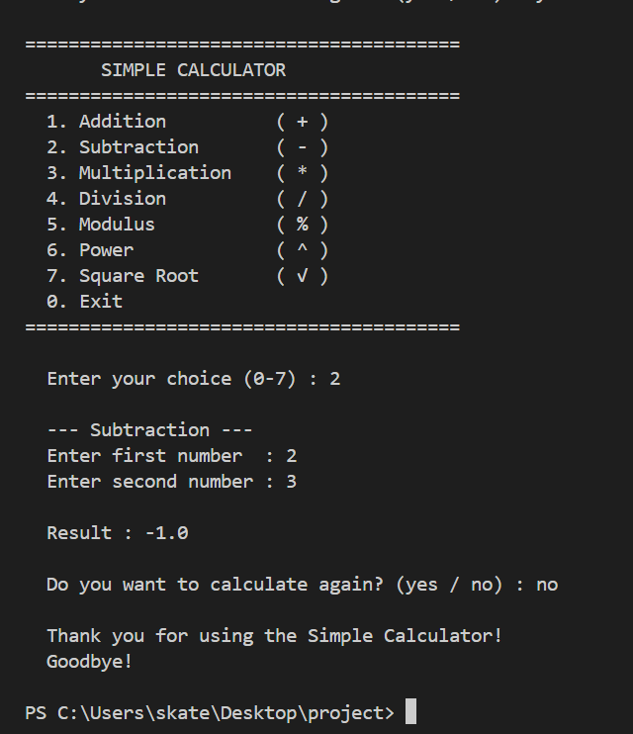

11. Testing Approach
Testing was conducted manually via terminal interactions, focusing on boundary cases:
- Valid Inputs: Standard integers and floats (e.g., 5, 2.5, -3).
- Invalid Formats: Letters and special characters (e.g., "A", "@").
- Mathematical Edge Cases: Dividing by 0.0[cite: 3] and requesting square roots of negative integers[cite: 3].
12. Challenges Faced
A core challenge was managing user input types, as Python's input() function natively returns strings[cite: 2]. This required building a robust validation step to cast inputs to floats safely without crashing the application when users mistakenly typed letters instead of numbers[cite: 3].
13. Learnings & Key Takeaways
[cite: 4]
- Proper implementation of the try-except block is critical for user experience[cite: 2].
- Breaking code into separate files (main.py, calculator.py, validator.py) vastly improves readability and logical structure.
- Docstrings are essential for documenting the purpose of individual functions[cite: 1].
14. Future Enhancements
[cite: 4]
- Integration of a graphical user interface (GUI) using Tkinter or PyQt.
- Addition of a history log to save previous calculations to a text file.
- Expansion of calculator.py to include trigonometric and logarithmic functions.
15. References
[cite: 4]
- Python Software Foundation. (n.d.). Python Language Reference, version 3. Available at http://www.python.org
- VITyarthi Python Essentials Course Materials.

